MULTISITE GRANT MANAGEMENT SYSTEM

Expense Approval Request

User Guide Document

-MGMS Ver. 1.8

Version History
Date | Description
28-Jan-2010 | First Draft

Table of Contents

Version History 2
1 Introduction 5
1.1 Purpose 5
2 Expense Request Evaluation 5
2.1 Initial Administrative Functions 6
2.1.1 Adding new users – finance department personnel: 6
2.1.2 Add New Role – ROLE_FINANCE 6
2.1.3 Creating approval Authorities: 6
2.2 Submission of Expense request by staff members 8
2.3 Expense Request approval 11
2.4 Payment 13

Table of Figures

Figure 1: Admin - Add new user 6
Figure 2: Site Admin - Add Approval Authority 7
Figure 3: Admin - Add members to approval authority 7
Figure 4: Admin - Edit approval authority 8
Figure 5: Staff - Add new expense request 8
Figure 6: Staff - Edit expense entry 9
Figure 7: Staff - expense entry - non editable 9
Figure 8: Clerk– Expense Request List 9
Figure 9: Clerk - View Request Details 10
Figure 10: Clerk - Approval status history 10
Figure 11: Clerk - Payment Entry 11
Figure 12: Approval authority – Evaluate Expense Request - List 11
Figure 13: Approval authority – Request Evaluation 12
Figure 14: Approval authority – Send request for further approval 12
Figure 15: Approval authority - evaluation not completed 12
Figure 16: Approval authority – Request cannot be sent 13
Figure 17: Clerk - multiple payment entries 14

Introduction

Purpose

This document provides the step-by-step instructions for the various activities associated with expense request evaluation and any approved payment within an organization using the Multisite Grant Management System application.

This is a ‘living document’ and the specification will change, continuously, as the project proceeds. More details will be added and the existing information edited as the requirements, architecture and design evolve in the course of the project.

Expense Request Evaluation

The salient features are as follows:

  - Multiple staff members can create and submit expense request to the organization, on behalf of their projects. Currently only PI users can enter expense requests on behalf of their projects.
  - The expense request details are captured on a fixed format screen in MGMS
  - The requests from the entire institution are received by a finance clerk who will start the routing process by selecting the first level approval authority. This role (Role_FINANCE) is to be created compulsorily
  - The same clerk can track the status of all requests – the level where the request is held up and the status.
  - Each of the submitted expense requests may go through multiple levels of evaluations, each of which is done by one or more individuals.
  - Currently, the routing of expense requests is not pre-set and for each expense request, the next approver can be decided by the previous one.
  - The PI can track the status of their expense requests in their login.
  - Corresponding to the approved expense requests, payment is made and the details can be recorded by the finance department personnel.
  - There is provision for capturing multiple payment records for each approved expense until the expense amount is covered.

Initial Administrative Functions

Adding new users – finance department personnel:
The various finance department personnel can be added by the Administrator through Add User page and the roles can also be assigned here.
Figure 1: Admin - Add new user
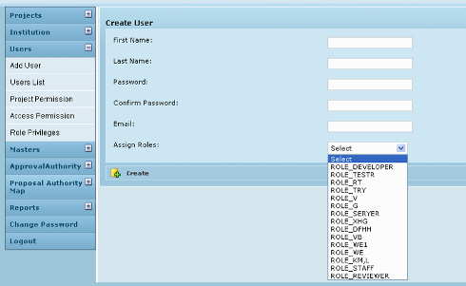

Add New Role – ROLE_FINANCE
If not already saved in the application, this role needs to be saved and assigned to the finance department user who needs to receive all requests from all projects running in the institution. Currently the same role also has the privilege to record payment details. Multiple persons may be assigned this role.
Any other roles required in the finance department can be added as per user’s choice.

Creating approval Authorities:
On the left menu panel, the administrator clicks on Approval Authority menu. It expands to display the sub menu – Add Approval Authority
On clicking Add Approval Authority, the page below opens up. Here each group of approving persons for expense requests at the institution is registered. Further, for each approval authority, the members are also added.

Figure 2: Site Admin - Add Approval Authority
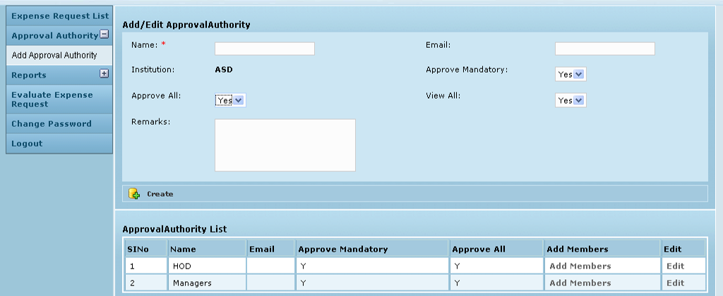
The fields bordered in red are mandatory.
The personal details are: Name of the group, group e-mail ID and Institution. Further, the Approve All field decides if all the particular group’s members’ approval is mandatory and it is set to “Y” (Yes) by default. View All is set to “Y” (Yes) by default which indicates that the members of this group are privileged to view all proposals even if they don’t get to review them. Approve Mandatory & View All are irrelevant in the current scenario.

In the Approval Authority List, for each line item (approval authority) , clicking on Add Members opens the page below, where members can be added to/removed from each Approval authority. The existing approval authorities are displayed in the table on the right (reviewer) from which selection can be made.
Figure 3: Admin - Add members to approval authority
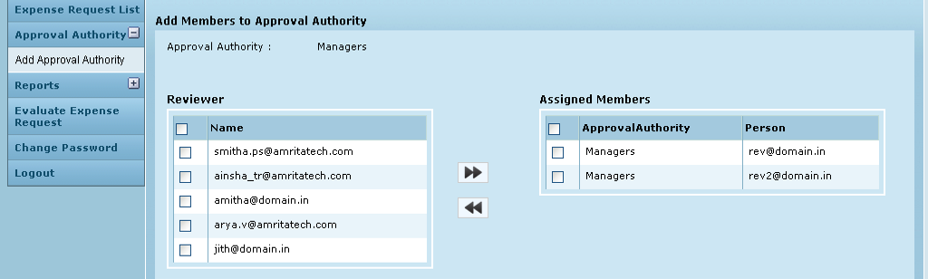
In the Approval Authority List (Fig 3), for each line item (approval authority), clicking on Edit, opens the page below, where any modification can be made.

Figure 4: Admin - Edit approval authority
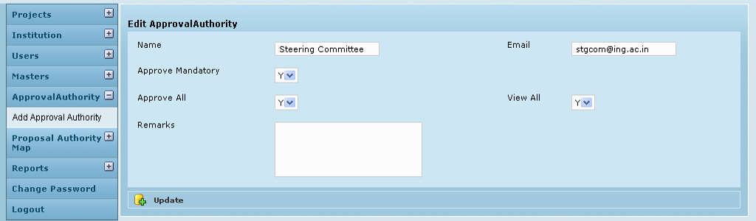

Please note that in case the finance department has only a single individual at each evaluation level, the approval authority can be given the name of the specific individual and just that single person assigned to it. Thereafter, at the time of selecting approval authority, the individual name can be selected for further routing.

Submission of Expense request by staff members
The staff includes those users who submit expense requests /proposals for evaluation. Currently this means only the PI of the various projects. The Staff logs into the application to create and submit expense requests to own institution for review. After logging in, user clicks Enter Expense Request Menu on the left panel. The page below is opened.
Figure 5: Staff - Add new expense request
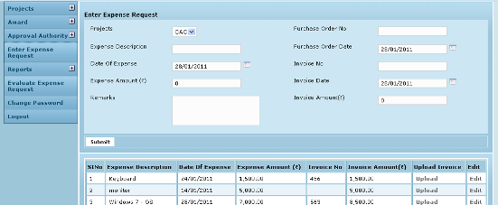
Purchase Order Date is the date of order for the items made to the vendor. Date of Expense is the day of receipt of the ordered items and Invoice Date is the date as on the bill accompanying the items. For certain purchases, it is not necessary to have Purchase Orders and then date of expense and invoice date are sufficient. It is also possible for all 3 dates to be the same.
The entire expense amount may not be paid in one go – so multiple invoices & receipts will be associated with it – each invoice will show a different invoice amount.
Documents can be uploaded (for e.g. PO, Quotations, invoices etc) to be reviewed by the approval authorities.
On clicking Submit, the institution’s expense request is displayed as a line item in the table below as well as in the finance clerk’s (who is privileged to receive all expense requests) Request List.
Later as the routing process progresses the status can be viewed in the Requests List table in (Fig 5).

Please note that the request can still be edited as long as the request is still with the clerk.
Figure 6: Staff - Edit expense entry
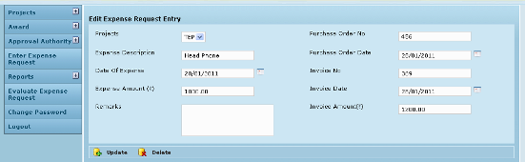
Once the clerk sends it for approval, Edit option is no longer available for the particular line item. Message is displayed as shown below and the user can only view the details.
Figure 7: Staff - expense entry - non editable
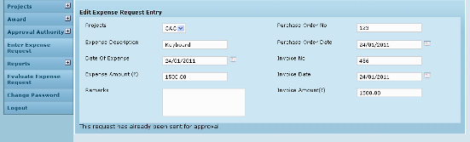

Finance Clerk:

The screen below shows the Clerk‘s list of expense requests which have been submitted so far from various projects and their status.

Figure 8: Clerk– Expense Request List
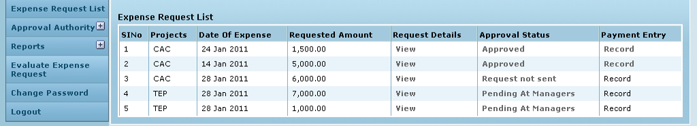

Clicking View for a line item in the column Request Details, the following page is opened:
Figure 9: Clerk - View Request Details
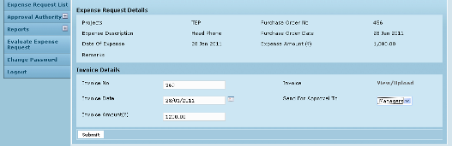
The invoice details are populated here and editable. The reason for this provision is to cover a scenario where the invoice is sent to the institution directly. In that case, the clerk will be capturing the invoice details. It is assumed that the purchase order details are completed by the staff/PI always.
Documents may be uploaded as well as existing attachments viewed by clicking link – View/Upload
On every Expense Request form, the clerk selects the first level for approving the form from the list box – Send for approval to. Then on clicking Submit, the request details get populated in the Request List tables of those belonging to that approval level. For e.g. if Asst Manager is selected, the line item goes to all asst managers added as members of that approval level. Whereas, if “Vishal Sharma” is selected, then it goes to Vishal Sharma’s Request List only since he is the only member of that approval level.

By clicking Status link in Approval Status column (Fig 8), a new window is opened where the Approval Status history can be viewed. The status set by each individual at every evaluation level is seen here and the clerk can know who submitted what evaluation result.

Figure 10: Clerk - Approval status history
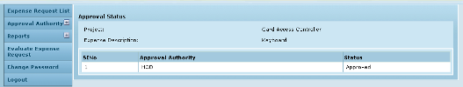

On clicking Record link in Payment Entry column, IF the request has been approved already, the following screen opens up – Fig 11. If not approved yet, then the link Record remains disabled.
Figure 11: Clerk - Payment Entry
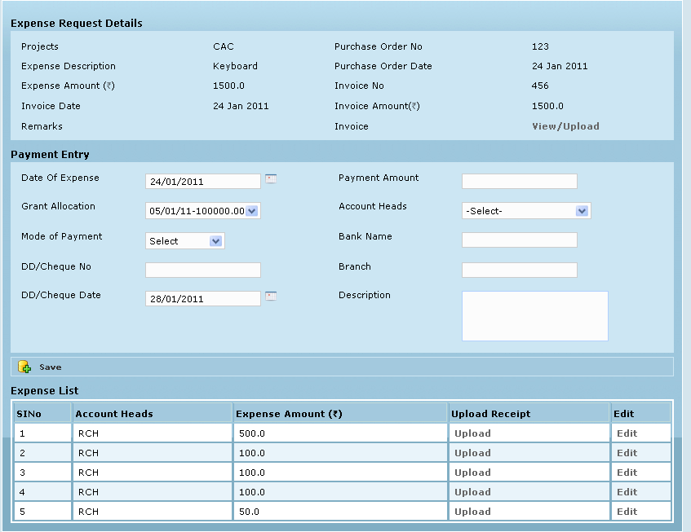

The evaluation process is described below:

Expense Request approval

The finance department approver logs in, clicks Evaluate Expense Request menu on the left. The list of expense requests expected to be reviewed by this employee at various evaluation levels is displayed here.
Figure 12: Approval authority – Evaluate Expense Request - List
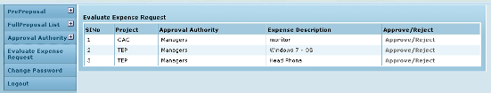
On clicking the “Approve/Reject” link in the Approve/Reject column, the specific expense request is opened and the approval authority is provided with 2 buttons – Accept & Reject, along with a field to enter comments.

Figure 13: Approval authority – Request Evaluation
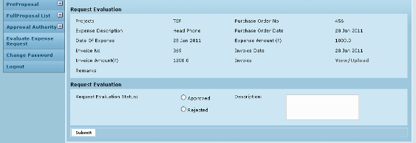

Once a suitable status (for e.g. Approved) is selected, the screen refreshes to display additional fields along with the message confirming successful completion of evaluation

Here (Fig 14), if the user is the final approver for this request then he can directly click button “Evaluation Completed”. The process ends and in the clerk’s Request List, the Record link is activated for entering payment details (Fig 8).

Figure 14: Approval authority – Send request for further approval
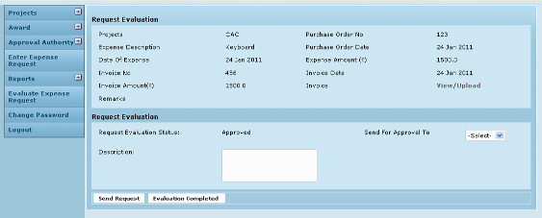

If there are multiple members for an authority level, then “Evaluation Completed” can be set only by the last member in that level. Else, the following message is displayed:
Figure 15: Approval authority - evaluation not completed
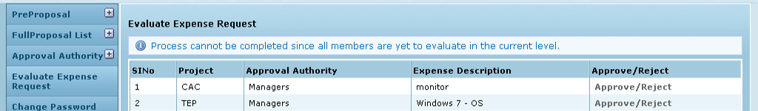

On the other hand, if the request needs to be sent to a different approval authority, the user selects the particular authority from the drop down list Send for approval to and then clicks “Send Request”. Here again, if the other members are yet to evaluate, only a message is shown.
Figure 16: Approval authority – Request cannot be sent
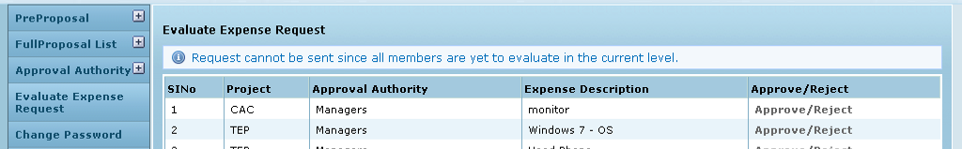

Once successfully evaluated by all members in a level and the request sent to the next level, the line item now populates the selected approval authorities’ lists. The process is repeated.

Please note that currently it is possible for an authority to “Reject” a request and still send it to a different authority. The final status of a request is the same as that set by the authority which clicked “Evaluation completed”.
Currently if the finance clerk tries to resend an item – message is displayed explaining that the evaluation process is already completed for the particular request.

Payment

Once a request gets approved, the Record link is enabled for the privileged user in the Payment entry column (Fig 8 – Expense Request List). By clicking this link, the user can open the Payment entry screen and record the transaction. It is possible to record multiple payments for the same expense – the only validation being that the total payment should not exceed the total expense. Currently it is expected that payment dates may be before, after on the day of expense.

Figure 17: Clerk - multiple payment entries
